Name:_______________________________________________ Block: ______________________
SHAPE OF THE EARTH NOTES
5 observations used to prove the earth is ROUND
Illustrations Explanation/Notes
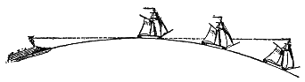  1.) | The Sinking Ship-
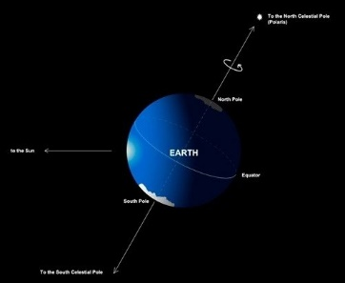  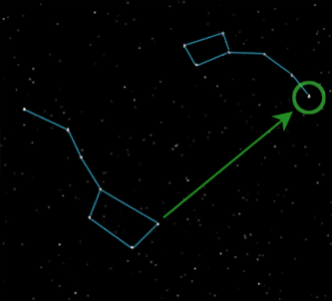  2.) | The Changing Altitude of Polaris (North) Star-
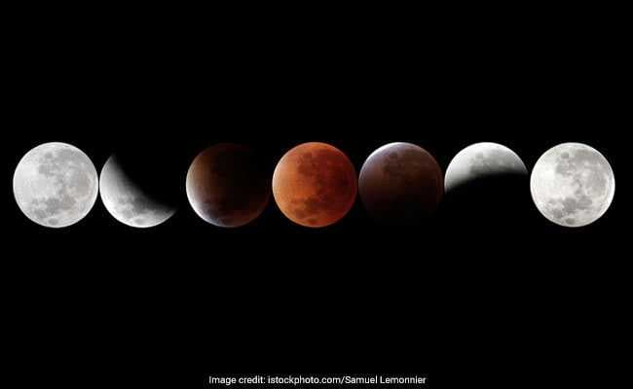  3.) | Lunar Eclipse-
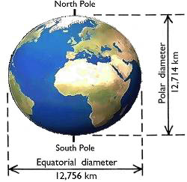  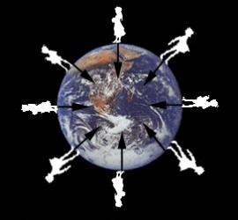  4. | Gravitational Strength-
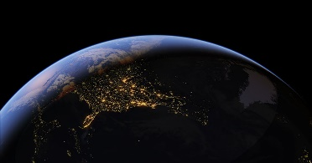  5. | Satellite Images-

Are there any additional observations you can think of?

